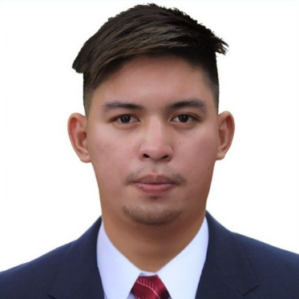
OBJECTIVE

DENOYO, ARIEL BALONDO

18 Dalton Pass Extension, Holy Spirit, Quezon City Philippines
0945-311-7358
denoyo03@gmail.com

PERSONAL DETAILS
Nickname: Ariel
Date of Birth: June 27, 1999
Religion: Roman Catholic
Height: 171 cm
Weight: 75 Kg

TECHNICAL SKILLS
Excellent in using Microsoft tools such as Word, Excel, Powerpoint etc. As well as Google suit such as managing Google drive, Docs, sheet, slides, forms, and calendar

SOFT SKILLS
Time Oriented – With excellent history in work attendance and finishing deliverables efficiently and effectively
People Oriented – With excellent interpersonal skills/relation among colleagues
Goal Oriented – With strong passion in driving towards the organization’s goal. Action being specific, measurable, attainable, realistic, and time bounded.

SPECIAL SKILLS
- Auditing
- Attention to details
- Multi tasking
- Reporting

To apply a post that is related to my expertise and continuously develop my leadership abilities

EDUCATION
Institute of Creative Computer Technology Colleges Foundation Inc.
V. Soliven Avenue II, San Isidro, Cainta, Rizal
Bachelor of Science in Information Technology – December 2018

EXPERIENCES
March 2024 Housekeeping/Cleaner/Public Area
March 07, 2024 – Present
Enviro Facility Management
Mobily # 966580276491

October 2022 Phone Contact Tracer/Disease Surveillance Officer
October 10, 2022 – March 04, 2024
Quezon City Health Department
Quezon City Epidemiology Surveillance Unit

November 2020 Contact Tracer/District Coordinator
November 1, 2020 – August 31, 2022
Department of Interior and Local Government

April 2020 Factory Worker/Machine Operator
April 01, 2020 – October 30, 2020
Asia Electronics Corporation

November 2019 Auditor/Cost Control, Staff/Room Service
November 21, 2019 – March 16, 2020
Manila Prince Hotel

March 2019 Food Checker/Food and Beverage Attendant
March 26, 2019 – November 20, 2019
The Manila Hotel

SCOPE and RESPONSIBILITIES
- Conduct phone interview with COVID-19 patients and their close
contact
- Inform or alert close contact to the possibility of infection and ensure
timely referral for management and care
- Fill-out COVID-19 case investigation google forms and close contact
forms for documentation and/or field investigation
- Attend basic training orientation/refresher courses on COVID-19
contact tracing flow and basic steps
- Alert supervisors regarding clustering of cases
- Coordinate with Barangay and other stakeholders
- Prepare and submit daily contact tracing report
- Perform other tasks assigned by the immediate supervisor
- Manages health data of patients from assigned districts after contact
tracing
- Assist in documenting patient data for COVID-19 testing
- Serve Food and Beverage
- Following food and safety regulations
- Handle customer complaints
- Greet customer
- Customer Service
- Explain menu offerings
- Duty to produce an audit report
- Duty to produce competent disclosure in an audit report
- Monthly conducting inventory supplies of Hotel
- Making SOA/Statement of Account
- Check and Balance all the receipt transactions like Food and Beverages
- Audit Representative for Cash Count Monthly Revenue
- Assemble machine parts, cleaning and organizing workspace, Operating machinery, Maintaining Quality Control, Packaging Finish Products.
- Greeting the Guest
- Present Menu to Customer
- Take and serve orders
- Offer menu recommendations upon request
- Communicating them effectively to the kitchen
- Carrying plates
- Dusting
- Vacuuming
- Changing bed linens
- Cleaning
- Mopping

CHARACTER REFERENCES

[ Available upon request]

ARIEL BALONDO DENOYO
APPLICANT NAME

